1.Your GitHub repository URL.
https://github.com/lawrencegtagoe-bluenest/hello-vercel

2.Your Vercel production URL.
https://vercel.com/lawrencegtagoe-bluenest/hello-vercel/7SbMFriD4v8HC4D85vhzutizU6PJ

https://hello-vercel-one-rust.vercel.app

A screenshot of the deployed page

SCREEN SHOT 1

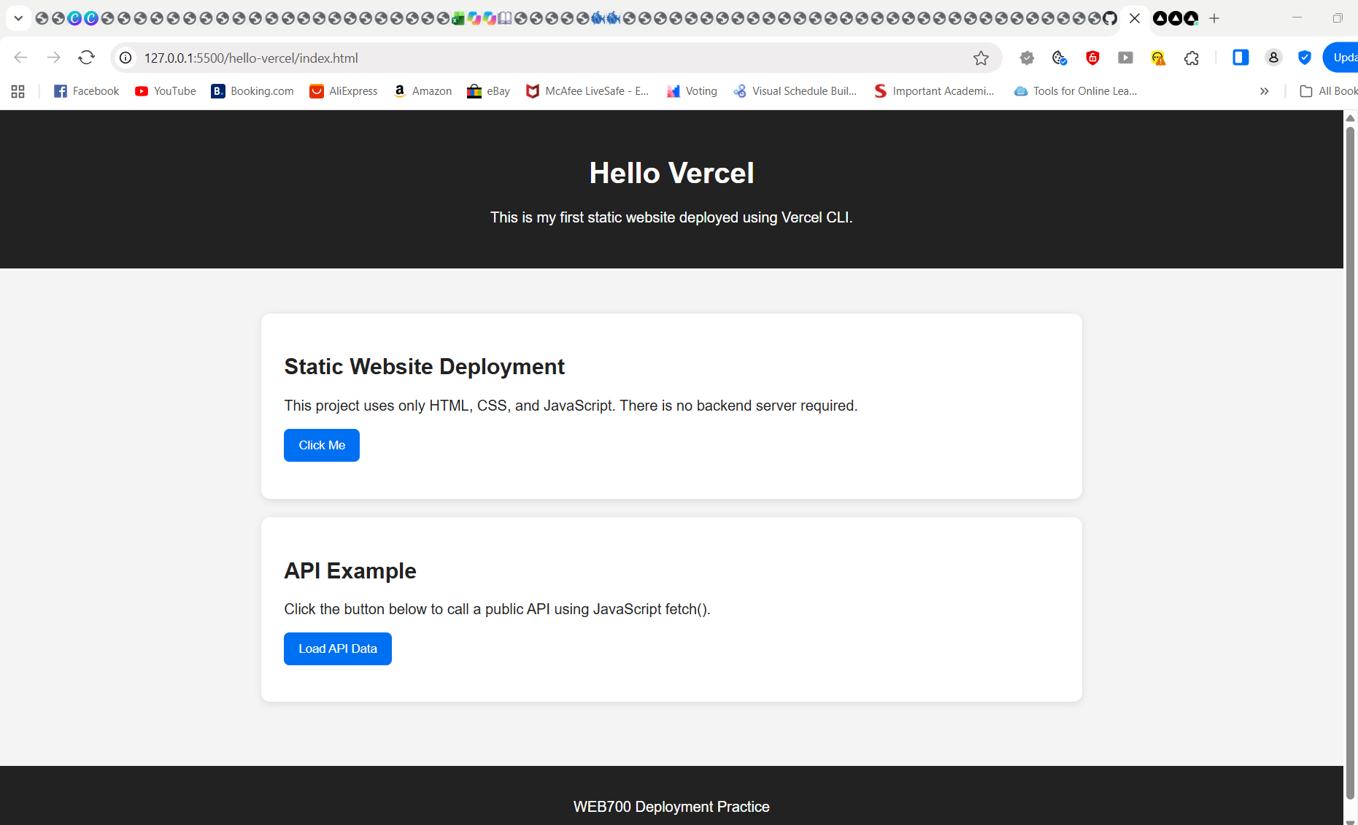

SCREEN SHOT 2

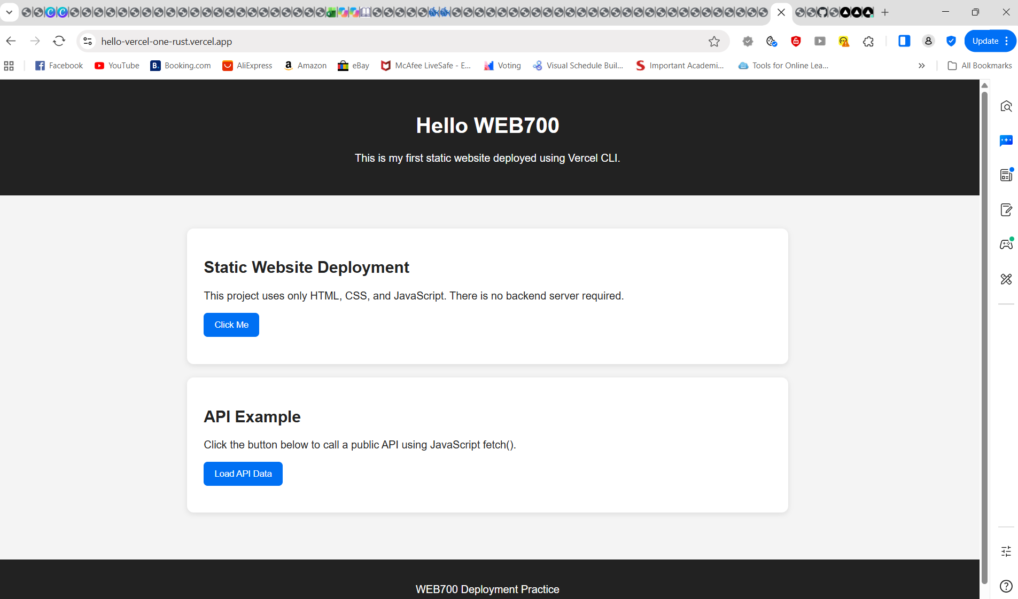

A short answer to this question:
What is the difference between hosting a static website and running a backend server?
The main difference is that a static website serves files to visitors, while a backend server runs code to process requests, handle data, and perform tasks behind the scenes.

